✍️ Quick notes

Cohort Call — Week 3 / Module 3 (Claude AI Certification)

Jul 12, 2026

marianna.nechypor@gmail.com chidioparah@gmail.com sudeunal3334@gmail.com Rifat Erdem Sahin

The session established AI learning methodologies and architectural patterns with a decision to produce educational video projects.

AI Learning and Certification Progress
- Sud completed Module 1 hands-on experience covering project summarization and architectural terms.
- Marianna prioritized strategy analysis over technical tasks due to academic commitments.
- Rifat introduced AI-driven PM skills marketplace to automate go-to-market strategy development.

Agentic Architecture and Multi-Agent Theory
- Agency defined as active decision-making capability distinct from standard robotic automation.
- Multi-agent systems utilize specialized agents—including coordinators, naive workers, and synthesis agents—to partition complex tasks.
- Architecture promotes modularity, enabling isolated updates to specific system components rather than system-wide rewrites.

Multimedia Learning and Workflow Implementation
- Multimedia learning framework employs visual, auditory, and verbal modalities to improve information retention.
- Canva utilized for storyboarding, script development, AI voiceover generation, and captioning.
- Table read method adopted to enhance comprehension of script roles and agentic flows.

Multimedia learning methodology
- Multimedia learning strategy implemented to facilitate exam preparation through storyboard creation and script alignment.
- Personalization of content using individual life references such as birthplace or local landmarks recommended for improved memory retention.
- Mastery of concepts prioritized over rote memorization to enable dynamic responses for non-static AI-generated exam questions.

Video editing and content workflow
- Students tasked with utilizing Magic Media in Canva to create and time visuals matching the provided audio script.
- Workflow involves listening to voice-overs, analyzing content, and selecting specific graphics to represent abstract agent concepts.
- Iterative refinement required to transform initial drafts into aesthetically professional final products.

Certification and career development strategy
- Continuous certification cycle of approximately 6 months anticipated due to rapid AI development.
- Exam passage serves as critical proof of competency for securing high-value technical roles in Western economies.
- Target set to demonstrate methodology efficacy through a cohort of 300 initial students.

Market and technology trend analysis
- Google Trends utilized for objective evaluation of technology stacks and investment of time.
- Competitive benchmarking performed for AI tools including Claude and Gemini using search data.
- DevOps historical search data indicates long-term growth trend originating from 2010.
- Marianna Nechypor and sudenall tasked with identifying relevant professional certifications via trend-based market analysis.

Video production and study workflow
- Initial video project assigned focused on 1st exam question.
- Rifat Erdem Sahin to evaluate submitted video content for improvement.
- Workflow expansion to 4 concurrent videos planned following demonstration of competency.

Multi-agent architecture concepts
- Hub and spoke design pattern identified as core framework for multi-agent architectures.
- Coordination of web search, document analysis, and synthesis agents clarified for integrated research output.
- Instructional emphasis shifted toward cognitive evaluation and conceptual internalization over rote memorization.
- Video editing in Canva recommended as technique for visualizing and retaining complex technical information.

Next steps
- [Marianna Nechypor] Complete Claude 101: Finish the course content next week.
- [The group] Build Animation: Construct the project by following the designated steps and storyboard.
- [Marianna Nechypor, sudenall] Update Multimedia Presentation: Listen to the voice over for the multimedia training, extract relevant keywords from the script, find corresponding graphics, and add them to the video presentation in the correct time slots.
- [Marianna Nechypor, sudenall] Perform Table Read: Read the acts and scenes of the script out loud as a table read to ensure comprehension of the roles and technical flow.
- [Marianna Nechypor, sudenall] Study Exam Question: Study the first exam question and analyze the provided concepts using the self learning methodology.
- [Marianna Nechypor, sudenall] Create Custom Video: Create a personal copy of the video project and edit it using custom imagery to reflect individual learning.
- [Rifat Erdem Sahin] Share Exam Materials: Post the first exam question, its answer, and the required exam format to the WhatsApp channel.
- [Marianna Nechypor, sudenall] Research Certification Trends: Research Google Trends to identify and select the most relevant certification for career goals.
- [Marianna Nechypor, sudenall] Take Mock Exam: Take the mock exam available on the platform to practice for the actual certification assessment.

You should review Gemini's notes to make sure they're accurate. Get tips and learn how Gemini takes notes
How is the quality of these specific notes? Take a short survey to let us know your feedback, including how helpful the notes were for your needs.

📝 Full notes
Jul 12, 2026

Cohort Call — Week 3 / Module 3 (Claude AI Certification)
Invited marianna.nechypor@gmail.com chidioparah@gmail.com sudeunal3334@gmail.com Rifat Erdem Sahin
Attachments Cohort Call — Week 3 / Module 3 (Claude AI Certification)
Meeting records Recording

Summary
The session established AI learning methodologies and architectural patterns with a decision to produce educational video projects.
AI Learning Frameworks
The group explored multimedia learning techniques and agentic skill marketplaces to improve concept retention. They established that understanding the difference between robots and agents is essential for advanced development.
Agent Architecture Patterns
Discussion focused on hub and spoke architectural patterns where specialized sub agents report to a central coordinator. This design reduces complexity and improves efficiency compared to monolithic agent models.
Trend Analysis and Decisions
The team analyzed historical technology trends using search data to guide career investment decisions. A decision was made to produce educational videos to master complex certification exam concepts.

Next steps
- [Marianna Nechypor] Complete Claude 101: Finish the course content next week.
- [The group] Build Animation: Construct the project by following the designated steps and storyboard.
- [Marianna Nechypor, sudenall] Update Multimedia Presentation: Listen to the voice over for the multimedia training, extract relevant keywords from the script, find corresponding graphics, and add them to the video presentation in the correct time slots.
- [Marianna Nechypor, sudenall] Perform Table Read: Read the acts and scenes of the script out loud as a table read to ensure comprehension of the roles and technical flow.
- [Marianna Nechypor, sudenall] Study Exam Question: Study the first exam question and analyze the provided concepts using the self learning methodology.
- [Marianna Nechypor, sudenall] Create Custom Video: Create a personal copy of the video project and edit it using custom imagery to reflect individual learning.
- [Rifat Erdem Sahin] Share Exam Materials: Post the first exam question, its answer, and the required exam format to the WhatsApp channel.
- [Marianna Nechypor, sudenall] Research Certification Trends: Research Google Trends to identify and select the most relevant certification for career goals.
- [Marianna Nechypor, sudenall] Take Mock Exam: Take the mock exam available on the platform to practice for the actual certification assessment.

Details
Did the screenshots in this section make your notes better or worse?
- Meeting Introductions and Connection Check: The meeting began with introductions and a technical check of the participants' internet connections. Rifat Erdem Sahin initiated the session by confirming the audio quality and noting that attendees were joining from different locations.
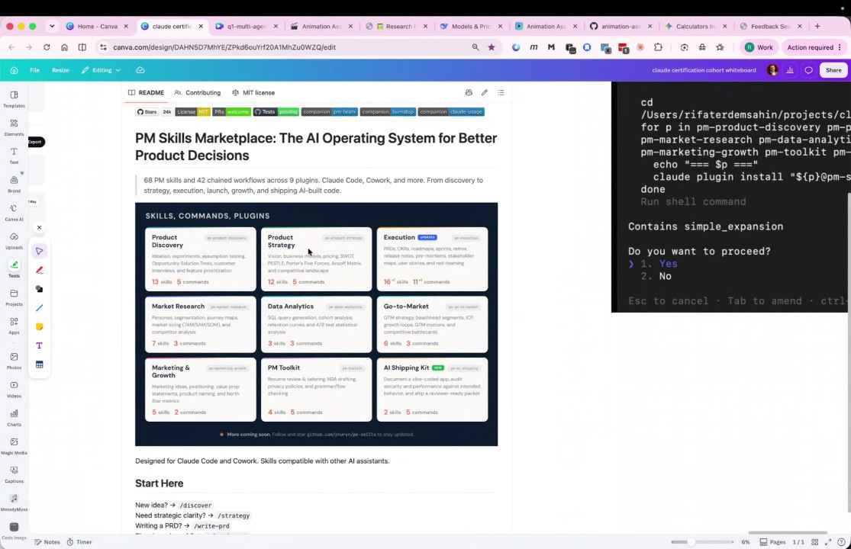
- Review of Previous Week's AI Progress: Sudenall reported completing the Module 1 hands-on experience, covering topics such as the "lost in the middle" project, summarization, jitter, request coalescing, circuit breakers, and structured escalations. Marianna Nechypor reported focusing on strategy analysis rather than technical coding and expressed an aim to finish the Claude 101 course in the following week.
- Go-to-market Strategy Definition: Rifat Erdem Sahin and Marianna Nechypor defined a go-to-market strategy as the process of researching and analyzing the market to define an ideal customer profile, determining how to position and sell a product, and iterating on those strategies.
- AI Skills Marketplace and Project Goals: Rifat Erdem Sahin demonstrated the use of an AI skills marketplace, which provides pre-built "agentic" skills for tasks like product discovery, data analytics, and go-to-market workflows. Rifat Erdem Sahin stated that the goal is to pass the Claude AI certification exam and learn to leverage these pre-built agent skills to assist in product management and development.
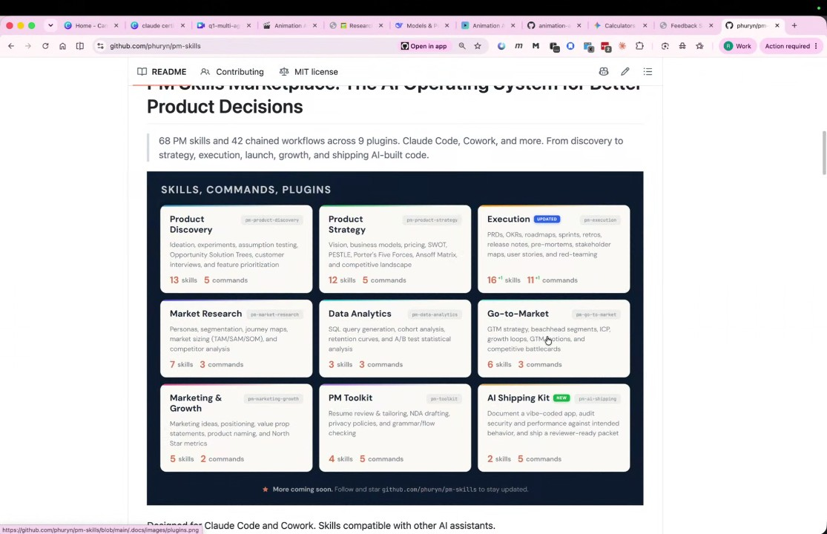
- Multimedia Learning Methodology: The team discussed the strategy of multimedia learning, which utilizes words, sounds, images, and verbal models to improve content retention. The objective is to learn complex AI concepts in a way that is easier to remember by engaging multiple senses.
- Calculators as an Analogy for AI: Rifat Erdem Sahin used the historical adoption of calculators to explain the potential impact of AI. When calculators were introduced, the number of people working in accounting professions increased rather than decreased, suggesting that AI will similarly skyrocket the capacity for financial management, coding, and other professional tasks.
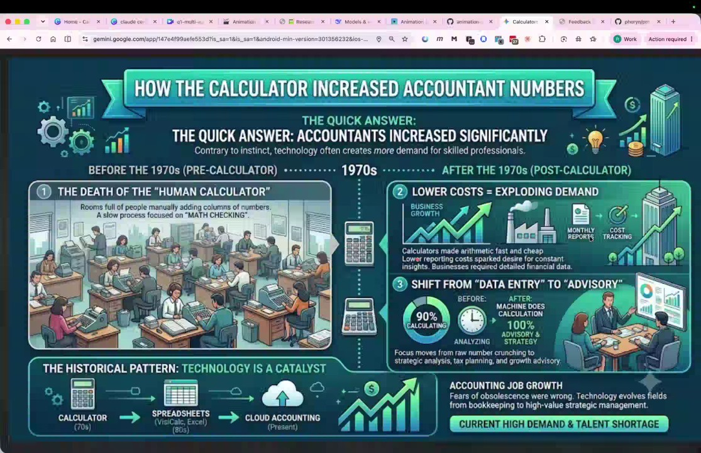
- Shift to Hands-on Training: Rifat Erdem Sahin emphasized that after the first five modules, the training will shift primarily to hands-on exercises. This shift aims to move beyond theory and allow participants to build their own agentic systems, websites, and skills.
- Importance of Prompt Engineering: The participants discussed the significance of knowing how to ask questions to AI. Sudenall shared that they were able to pull and run code from GitHub by consulting AI, illustrating that the ability to query AI effectively is a crucial skill.
- Hardware and Software Robots: The discussion highlighted that a hardware robot is essentially a software robot with a physical body. Software robots operate on computers to perform tasks, while hardware robots execute those tasks in the physical world. It was noted that modern software robots can operate continuously, such as running a task for two days and twelve hours without pause.
- Multi-Agent Systems and Coordination: Rifat Erdem Sahin explained that modern AI involves multi-agent systems where a coordinator schedules tasks for sub-agents. This represents a shift from a "single robot" model to a "multi-robotic" world, similar to how human household management requires multiple distinct roles.
- Defining Agency: The group clarified the difference between a robot and an agent: robots perform tasks, while agents possess "agency," meaning they have the capacity to make decisions within a given context. Future programming exercises will focus on creating systems where agents make informed decisions.
- Three-Act Structure in Learning: Rifat Erdem Sahin introduced a three-act structure for the course content: Act 1 covers the problem, Act 2 covers the decision-making solution, and Act 3 covers the transformational lesson. This narrative structure is designed to help participants understand and apply AI concepts.
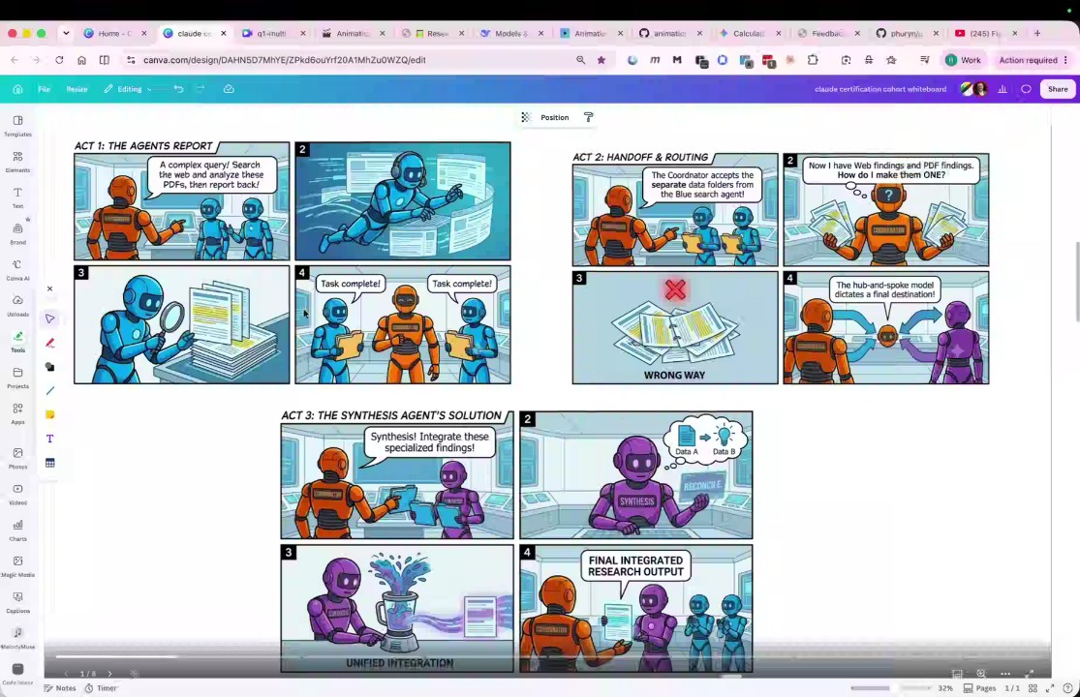
- Bloom's Taxonomy and Skill Acquisition: The group reviewed Bloom's taxonomy in the context of their training, moving through the stages of remembering, understanding, applying, analyzing, evaluating, and creating AI agent systems. This framework ensures participants can move from simply identifying what a robot is to designing complex multi-agent architectures.
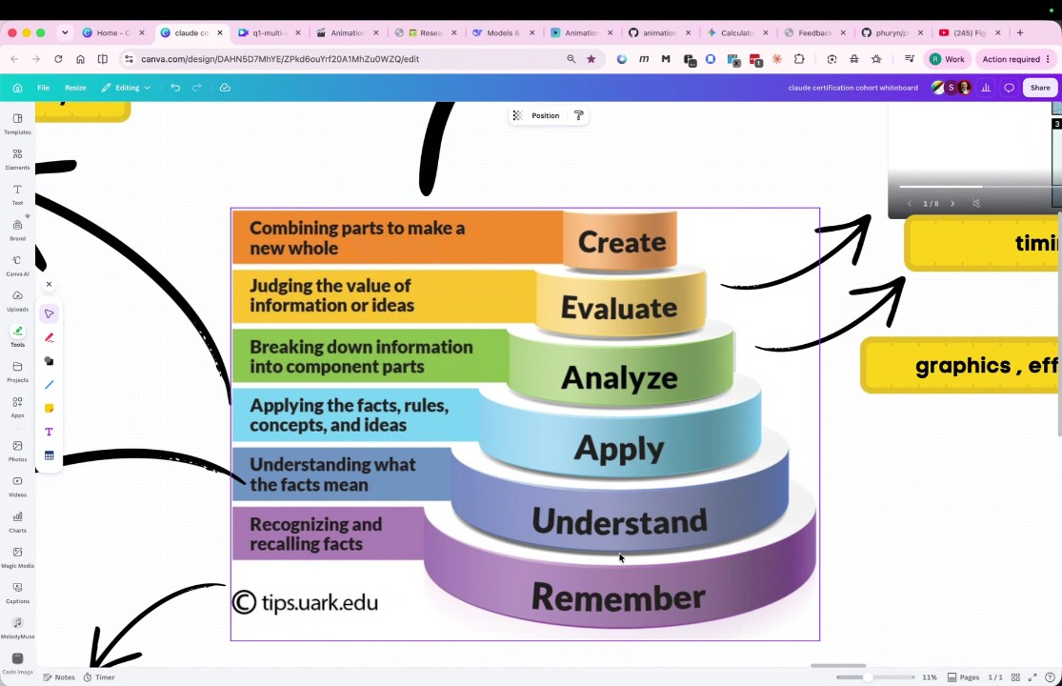
- The Hub and Spoke Pattern: Rifat Erdem Sahin explained the hub and spoke architecture as a key design pattern for AI agents. In this pattern, a central coordinator manages multiple sub-agents that perform specialized tasks.
- Managing Agent Complexity and Cost: The group discussed why specialized agents are necessary; giving one agent too many responsibilities (e.g., "mom, boss, immigrant") leads to exhaustion and increased costs. By dividing tasks among specialized agents, the system becomes more manageable and efficient.
- Agentic Workflows for Research: Participants discussed the efficiency of using agents for research tasks, such as searching the web and analyzing PDF reports. Automating these multi-step processes with agents saves significant time compared to manual searching.
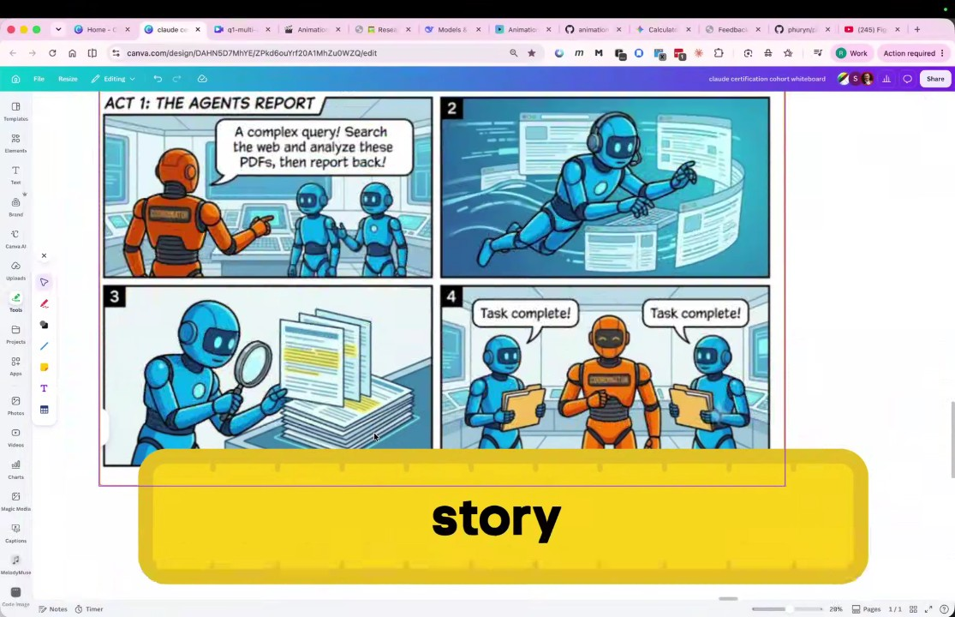
- Google Search versus AI Search: Rifat Erdem Sahin and the group compared traditional keyword-based Google searches with AI searches. While AI searches are more expensive and consume more energy, they can provide synthesized answers rather than just a list of links.
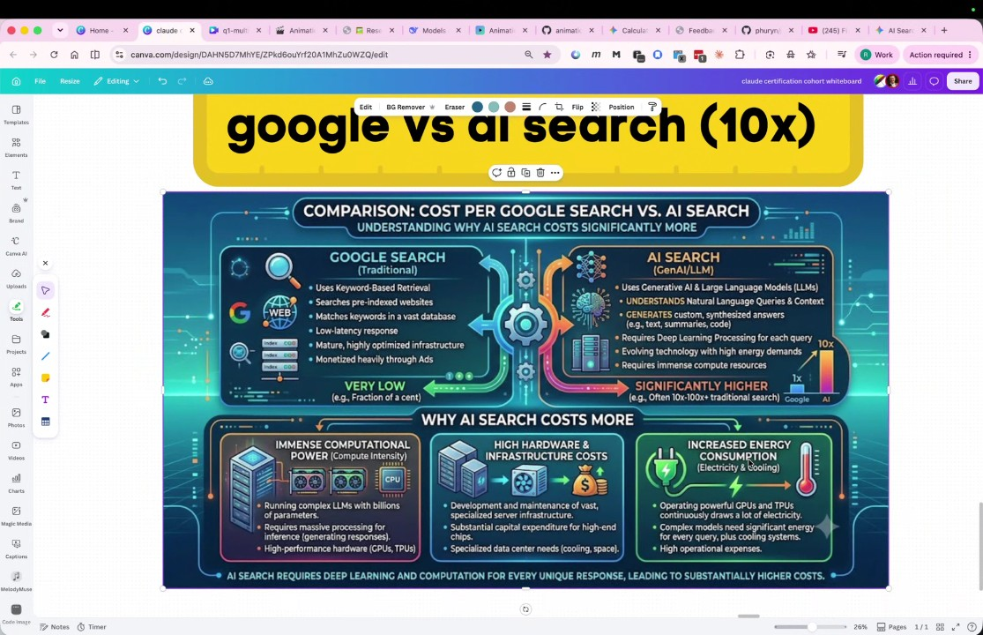
- Accuracy and Hallucination: The group acknowledged challenges with AI, such as the potential for hallucinations or inability to access specific context if not prompted correctly. However, they noted that AI benchmarks regarding accuracy are steadily improving year over year.
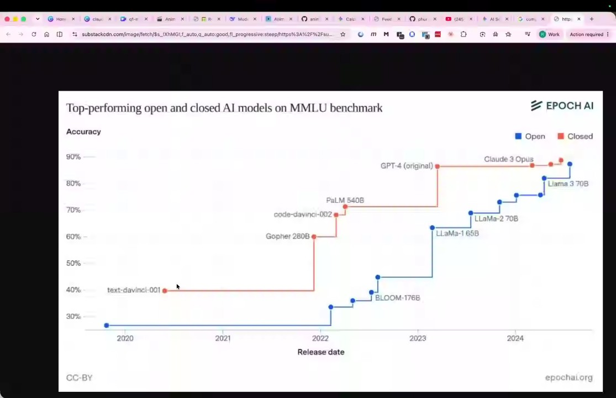
- The Role of the Synthesis Agent: In multi-agent patterns, a "synthesis agent" is required to integrate findings from various search agents into a single, cohesive document, preventing confusion when dealing with large volumes of data.
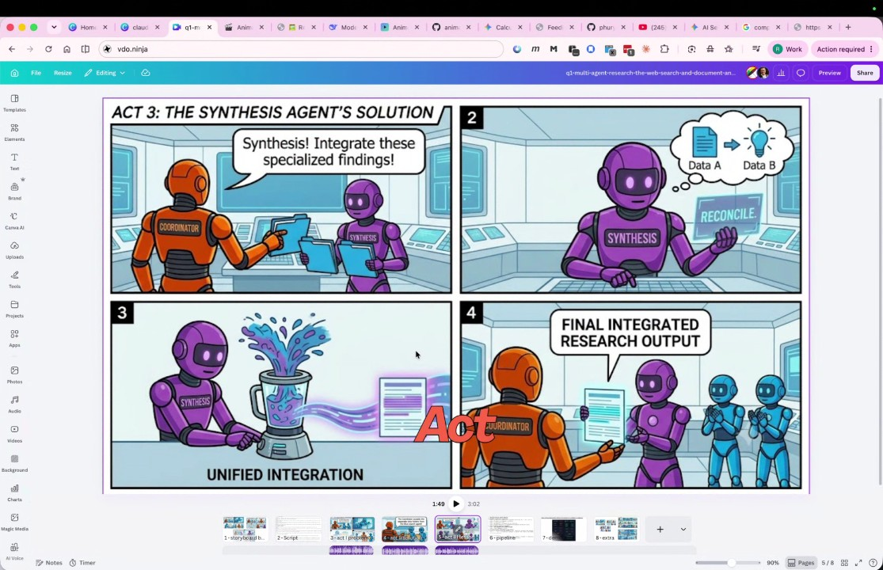
- Practical Canva Exercises: The session included practical work in Canva, where participants learned to add AI voice-overs to slides and generate captions. Rifat Erdem Sahin guided the participants on using the "Add Audio" and "AI Voice" features to create multimedia learning materials.
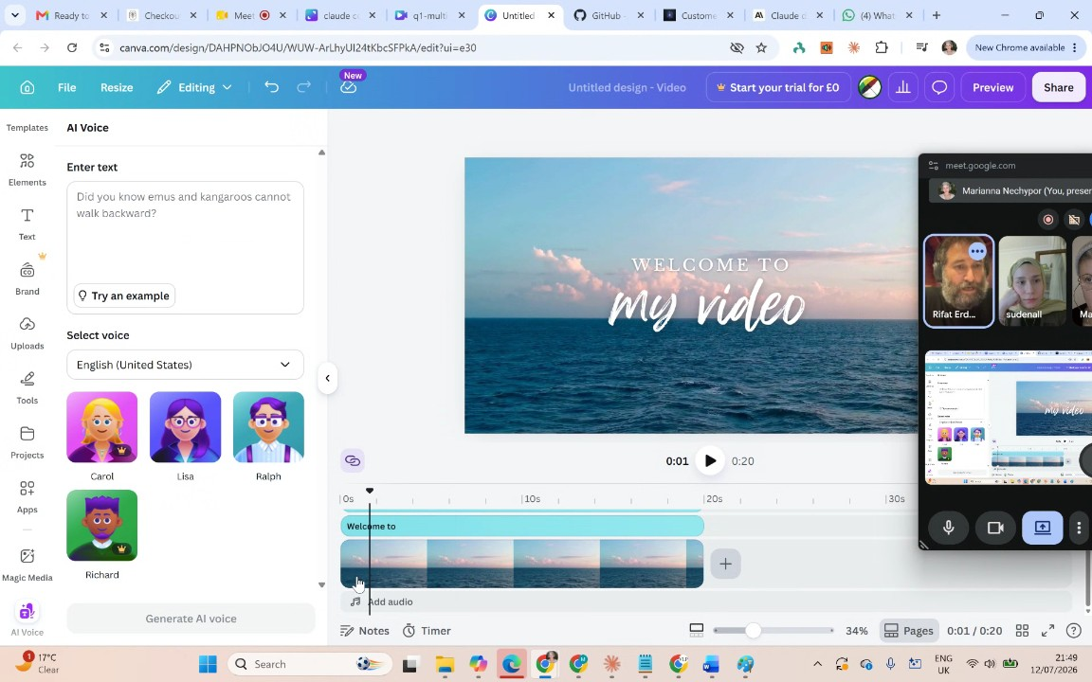
- Multimedia Learning for Retention: The participants confirmed that visual and auditory engagement—using images, audio, and captions—is critical for recalling complex information. By creating these "movies" (storyboards/scenarios), the concepts become easier to understand and remember.
- Keyword Extraction and Categorization: Rifat Erdem Sahin demonstrated how to use AI tools like Gemini to extract and categorize important keywords from the course transcripts into tables with definitions. This process is essential for internalizing the vocabulary needed to pass the certification exam.
- Table Reads and Understanding Roles: Rifat Erdem Sahin compared the learning process to "table reads" performed by actors in films. By reading scripts aloud and participating in table reads, learners can better understand their roles, evaluate whether they have grasped the concepts, and effectively prepare for the evaluation and creation stages of the project.
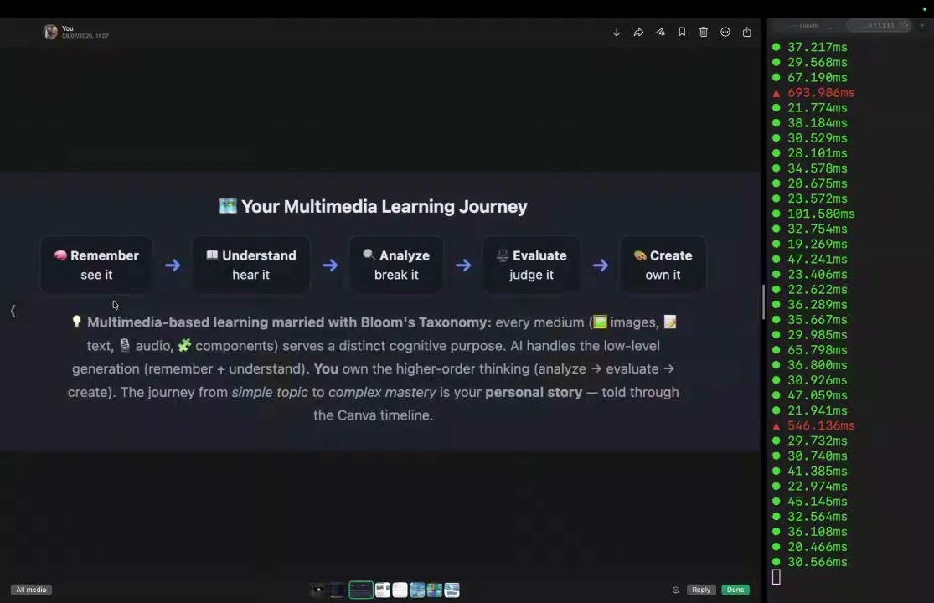
- Analysis versus Evaluation: Rifat Erdem Sahin defines analysis as breaking information into distinct parts (e.g., listing potential attack targets) and evaluation as the critical decision-making process involving timing and implementation. The participants discuss how understanding these concepts is necessary to pass the upcoming certification exams.
- Project Goal and Methodology: The participants are tasked with creating a "cohort" video by constructing a timeline that combines voice-over scripts with relevant imagery. This process involves gathering artifacts, conducting analysis, and evaluating where to place visuals to create a cohesive story.
- Tool Usage in Canva: Rifat Erdem Sahin introduces "Magic Media" within the Canva platform as the primary tool for generating AI images. They explain that the participants will use this tool to build visual representations of their learning materials.
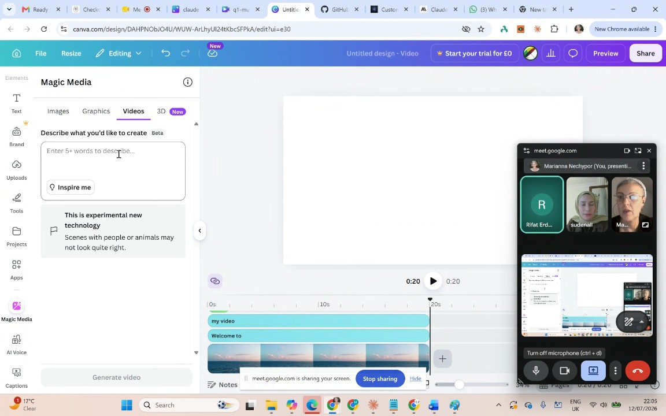
- Technical Connectivity and Access: The participants encounter intermittent internet connectivity issues due to the location of Rifat Erdem Sahin. They resolve document access hurdles by sharing and accepting links to ensure all parties can collaborate on the video project in real-time.
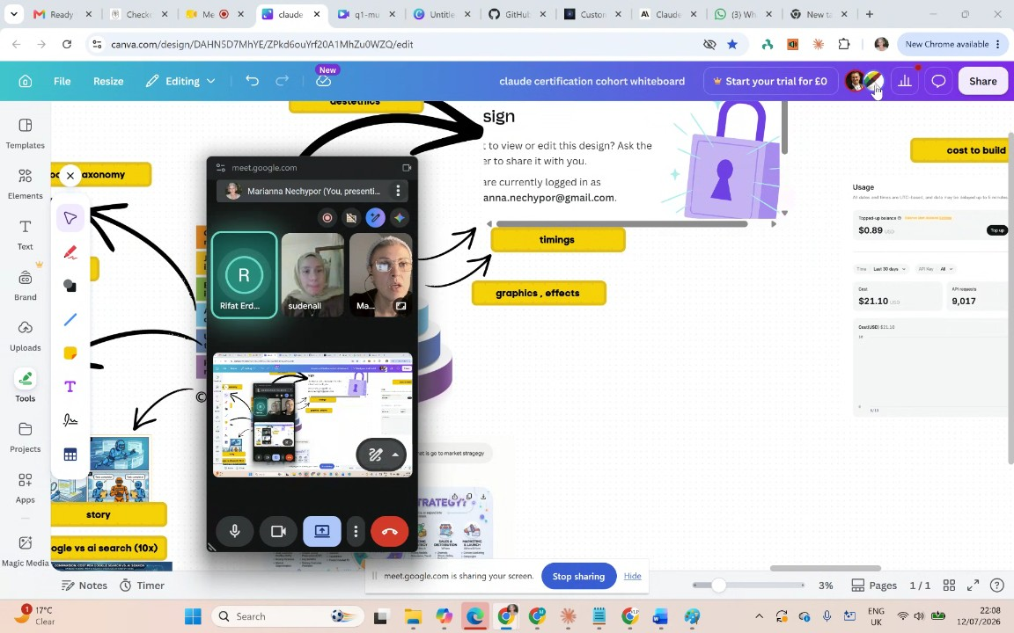
- Image Prompting Strategy: Rifat Erdem Sahin instructs sudenall and Marianna Nechypor to keep their AI image prompts simple, aiming for a visual complexity level suitable for a six-year-old. They emphasize that using fewer, clearer keywords prevents the AI from becoming confused and results in better visuals.
- Workflow for Content Creation: The team agrees on a specific workflow: listen to the voice-over, analyze the script to identify key concepts, and then locate or create corresponding visuals to match the timeline. Participants must learn to map specific words to the correct imagery to aid memory.
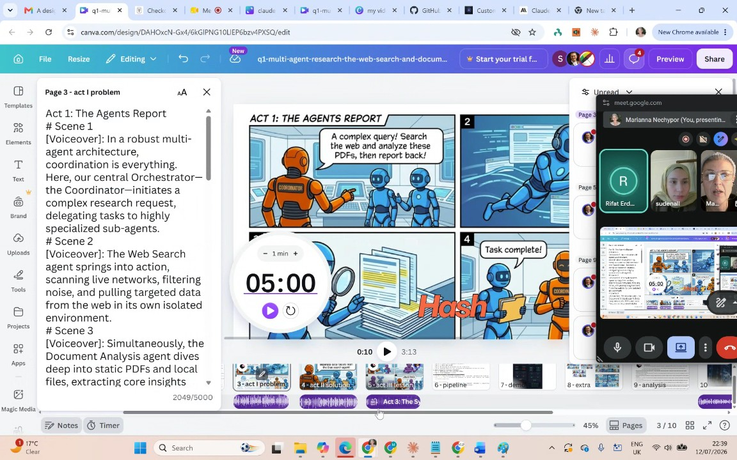
- Self-Learning Pipeline: Rifat Erdem Sahin outlines a self-learning pipeline where the participants read the script—divided into three acts—out loud to themselves. This exercise is designed to help the participants internalize the content and understand how to manage complex tasks like those performed by web agents and document analysis agents.
- Iteration and Aesthetic Quality: The participants acknowledge that their initial video drafts will likely be "ugly". Rifat Erdem Sahin emphasizes that they must iterate on their work to make the presentation aesthetically beautiful, which serves as a metric for confirming that they have truly understood the underlying concepts.
- Personalization of Learning: Rifat Erdem Sahin encourages sudenall and Marianna Nechypor to customize their videos by using personal references from their own lives (e.g., Cambridge or Metro) to create a "memory palace". This personalization makes abstract concepts easier to retain.
- Nature of the Pearson Exam: The group discusses the requirements of the Pearson exam, which costs between $200 and $500. Rifat Erdem Sahin explains that the exam is not a static test based on rote memorization, but a dynamic evaluation that adapts to the test-taker, making deep understanding essential for success.
- Professional Strategy and Sustainability: Rifat Erdem Sahin notes that in the current era of artificial intelligence, certifications may only remain relevant for six months, necessitating a habit of continuous learning. The objective is to help the participants pass the exam and build valuable skills in handling systems that utilize advanced, automated sub-agents.
- Technology Stack Analysis via Google Trends: Rifat Erdem Sahin guides sudenall and Marianna Nechypor on how to use Google Trends to evaluate career investments by comparing the search popularity of various technology stacks. Rifat Erdem Sahin demonstrates the process of using the plus sign feature to add multiple terms, such as Java and Python, to a single chart. Setting the time range from 2004 to the present, Rifat Erdem Sahin points out that interest in Java has declined significantly, while interest in Python has risen, suggesting that this data helps individuals decide which technologies to invest their time and money in for future job prospects.
- Comparing Generative AI Models: The group attempts to refine their market analysis by comparing specific AI models using the same Google Trends methodology. Marianna Nechypor and Rifat Erdem Sahin work to standardize the search queries to include Claude, Google Gemini, and OpenAI's ChatGPT. Rifat Erdem Sahin observes that Google Gemini currently shows higher search interest than Claude. The participants also discuss the potential to include other terms like AI Codex in their comparisons to better understand current market trends, despite some initial challenges in configuring the tool correctly for a multi-variable analysis.
- Long-Term Trend Analysis and Career Strategy: Using "DevOps" as a case study, Rifat Erdem Sahin illustrates how to identify long-term professional trends. By setting the data marker to 2010, Rifat Erdem Sahin shows that it took approximately 15 years for the DevOps trend to mature and reach its current prominence. Rifat Erdem Sahin explains that this type of historical visualization is essential for identifying upcoming high-value areas, such as cloud AI certificates, which they believe will be important in the enterprise sector.
- Video Editing Assignment: Rifat Erdem Sahin assigns the team the task of producing an educational video based on the first question of their mock exam, marking the start of a series where they will eventually produce up to four videos. Rifat Erdem Sahin encourages the participants to take ownership of the creative process, offering to review their work and answer questions throughout the week regarding video editing, including technical aspects such as audio, visual elements, and the timing of animations.
- Multi-Agent Architecture Exam Question: Rifat Erdem Sahin discusses the first question of a 60-question mock exam involving a multi-agent system. Rifat Erdem Sahin explains the scenario where a web search agent and a document analysis agent must collaborate. Rifat Erdem Sahin clarifies that in a "hub and spoke" architecture, these specialized sub-agents must report their findings to a central coordinator, which then routes the data to a synthesis agent for final integration. Rifat Erdem Sahin stresses that participants must learn to visualize these structural concepts mentally to correctly answer exam questions, as they will not be provided with diagrams.
- Hub and Spoke Pattern and Learning Methodology: Rifat Erdem Sahin details the reasoning behind the correct answer, explaining that bypassing the coordinator or having agents report directly to a reporting agent would fail to leverage integrated intelligence. Rifat Erdem Sahin highlights that the goal of this exercise is not merely to memorize the exam question, but to learn how to evaluate and decompose complex AI concepts, such as the hub and spoke pattern. Rifat Erdem Sahin emphasizes that developing this analytical capability is crucial for them to handle the scale and complexity of AI technologies in their future work.

You should review Gemini's notes to make sure they're accurate. Get tips and learn how Gemini takes notes
How is the quality of these specific notes? Take a short survey to let us know your feedback, including how helpful the notes were for your needs.

